**Model Development Phase Template**

|  |  |
| --- | --- |
| Date | 29 April 2025 |
| Skillwallet ID | **SWUID20250148853** |
| Project Title | **Uncovering the Hidden Treasures of the Mushroom Kingdom: A Classification Analysis** |
| Maximum Marks | 10 Marks |

**Initial Model Training Code, Model Validation and Evaluation Report**

**Initial Model Training Code**

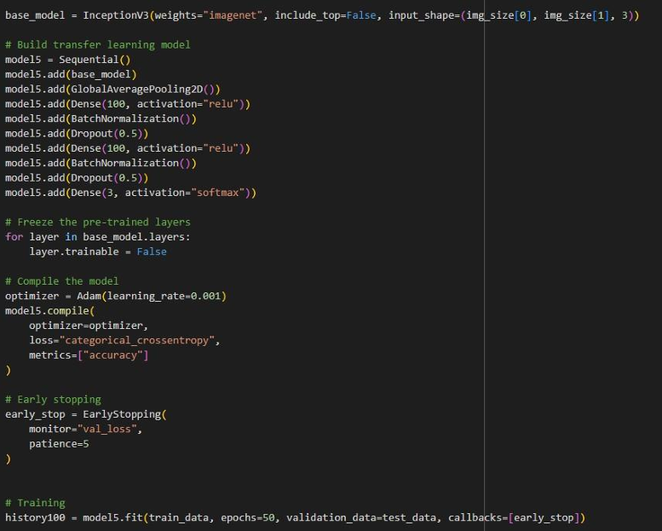

**Model Validation and Evaluation Report**

|  |  |  |
| --- | --- | --- |
| **Model** | **Summary** | **Training and Validation Performance Metrics** |
| **Model 1**  (InceptionV3 + Custom Layers) | **Layer Summary:** • InceptionV3 base model • GlobalAveragePooling2D • Dense(100, relu) • BatchNormalization • Dropout(0.5) • Dense(3, softmax)  **Total Parameters:** 2,311,305 **Trainable Parameters:** 2,304,505 **Non-trainable Parameters:** 6,800 | **Training Accuracy**: 83.42% **Validation Accuracy**: 88.36%  Training converged well with slight overfitting mitigated by dropout and batch normalization. |